# Business Requirement Document (BRD)

## Project Title:

Enhancement for Visual Indicators and Flighting Details in Placement Grid

## Problem Statement

Currently, in Nexelus, users can choose between manual and automatic flighting for placements in the media plan. However, there is no visual indicator at the placement grid level to identify which flighting method is being used for a specific placement. Users must open the placement details popup to view or edit flighting information, adding unnecessary steps to their workflow. Furthermore, flighting details are not included in the media plan export, making it difficult to review and analyze the complete plan. These limitations reduce efficiency and hinder the user experience.

This enhancement aims to streamline access to flighting details by providing visual indicators, a dedicated popup for editing flighting, and an export column to include flighting information.

## Objectives

1. Provide a visual indicator in the placement grid to identify the flighting type (manual or automatic).

2. Allow users to view flighting details by hovering over the visual indicator.

3. Enable users to edit flighting details directly through a popup accessed from the visual indicator.

4. Include flighting details in the media plan export for better visibility and analysis.

## Scope

### In Scope:

1. Adding a visual indicator (icon) to the placement grid to identify flighting type.

2. Implementing hover functionality to display flighting details as a tooltip.

3. Allowing users to click the visual indicator to open a popup for flighting details.

5. Adding a new column in the export file to include flighting details.

### Out of Scope:

1. Icon design for the visual indicator (to be decided separately).

2. Allowing users to switch between manual and automatic flighting from the popup.

3. Using the new flighting column for imports.

## Business Rules

1. The visual indicator will be displayed only for manually flighted placements in the grid.

2. Hovering over the indicator will display the complete flighting details in a tooltip.

3. Clicking on the indicator will open a popup showing:

- Read-Only Fields: Site Name, Placement Name

- Editable Fields: Flighting details (e.g., dates, spend, impressions). Start and End date, Cost Type and Unit Type.

4. All existing validations for flight editing will apply.

5. The media plan export will include a new column for flighting details. The format of this column will be finalized later but will not support imports.

## Functional Requirements

### Grid Enhancements

1. Add a new column to the placement grid for the visual indicator.

2. Display the indicator only for manually flighted placements.

3. Implement hover functionality to display flighting details as a tooltip.

4. Make the indicator clickable to open the flighting details popup.

### Popup Enhancements

1. Display the following fields in the popup:

- Read-Only: Site Name, Placement Name.

- Editable: Detailed flighting information (dates, spend, impressions, etc.), start date, end date, cost type and Unit Type.

3. Apply all existing validations for flight editing.

### Export Enhancements

1. Add a new column in the media plan export to display flighting details.

2. Ensure the column is export-only and not used for imports.

## Non-Functional Requirements

1. The addition of the visual indicator should not negatively impact the performance of the placement grid.

2. The export functionality should include the new column without causing significant processing delays.

3. The popup must be user-friendly and consistent with the existing UI/UX design standards.

## Risks

1. User Confusion: Users may expect to switch between manual and automatic flighting in the popup, which is out of scope.

- Mitigation: Clearly indicate that the popup is only for editing flighting details and not for changing flighting type.

2. Export Size Increase: Adding flighting details to the export file could increase file size.

- Mitigation: Ensure the export format is optimized for readability without adding unnecessary data.

3. Tooltip Usability: Tooltips displaying flighting details could become cluttered or hard to read if a placement has numerous flights.

- Mitigation: Implement scrolling functionality within the tooltip to ensure all flighting details are visible and the layout remains user-friendly.

## Assumptions

1. Flighting functionality will remain consistent with the current implementation in terms of rules and validations.

2. The icon design for the visual indicator will be finalized and provided separately.

3. Exporting flighting details in a new column will not affect the import process.

## Deliverables

1. Updated placement grid with visual indicators for manually flighted placements.

2. Tooltips on the placement grid to display flighting details with scrolling functionality for long content.

3. Popup for viewing and editing flighting details, including dynamic updates for totals and start/end dates.

4. Enhanced export functionality to include flighting details in a new column.

## UI Mockups

**Placement Grid UI:**

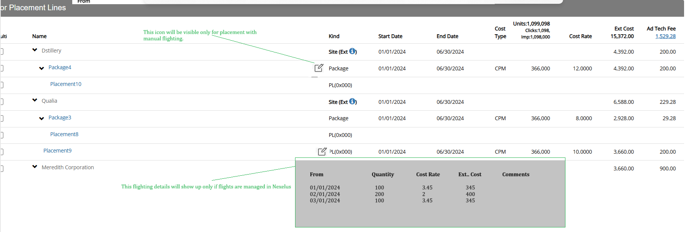

Flighting Popup. This popup will show up once user clicks on flighting Icon.

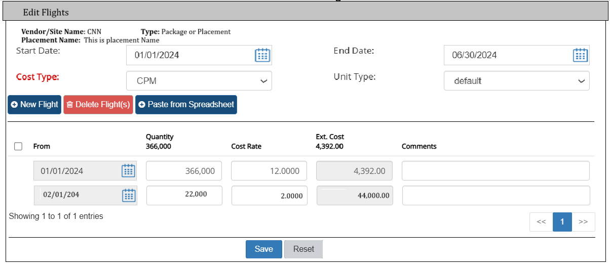

Please make sure to update AdTech calculation if amounts / units are changed.

Following are the validations on flight editing.  
  
1 - Flight From date cannot be outside of placement start and end date.

2 – Placement Start and End data cannot be outside of Media Plan dates.